If-clause type 1 + one/ones test – Wie wird es gebildet?

Kreuze pro Frage immer nur eine Antwort an!

name:__________________________________ class:_______ mark:_____/10 grade:______

1. If Mark _____ a customer, his boss will be happy.

☐ helps ☐ helping ☐ help

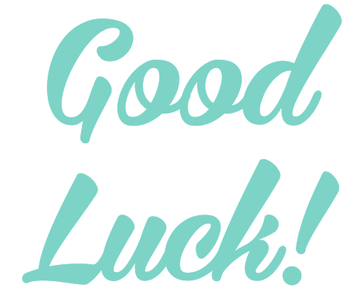

2. Will you come home early if I _____ dinner?

☐ will make ☐ make ☐ makes

3. If I take the school book home, I ______ it back next time.

☐ ‘ll brought ☐ will brought ☐ ’ll bring

4. If I have to cut vegetables all day, it _______ easy.

☐ won’t be ☐ isn’t be ☐ wasn’t be

5. He _____ to work on a Saturday if his boss calls him.

☐ ‘ll will go ☐ goes ☐ ‘ll go

6. If Andrea _____ earlier today, she’ll earn less money.

☐ will leave ☐ leaves ☐ leaving

7. “I’d like to buy these sunglasses.” – “Which ______?”

☐ ones ☐ one

8. “The blue one is great!” – “So you buy ______?”

☐ this shirt ☐ the shirts

9. “I want to read an English book and a German book.” – “OK. Which ____ should I get for you?”

☐ one ☐ ones

10. “I’d like to eat some donuts today. Should I get the pink _____?”

☐ one ☐ ones

